**Phase 6: User Interface Development**

1. **Lightning App Builder**
   * Setup → App Manager → New (Create NGO App)
   * Setup → App Manager → NGO App → Edit → Add Tabs (Donors, NGOs, Food Donations, Pickup Requests, Dashboards)

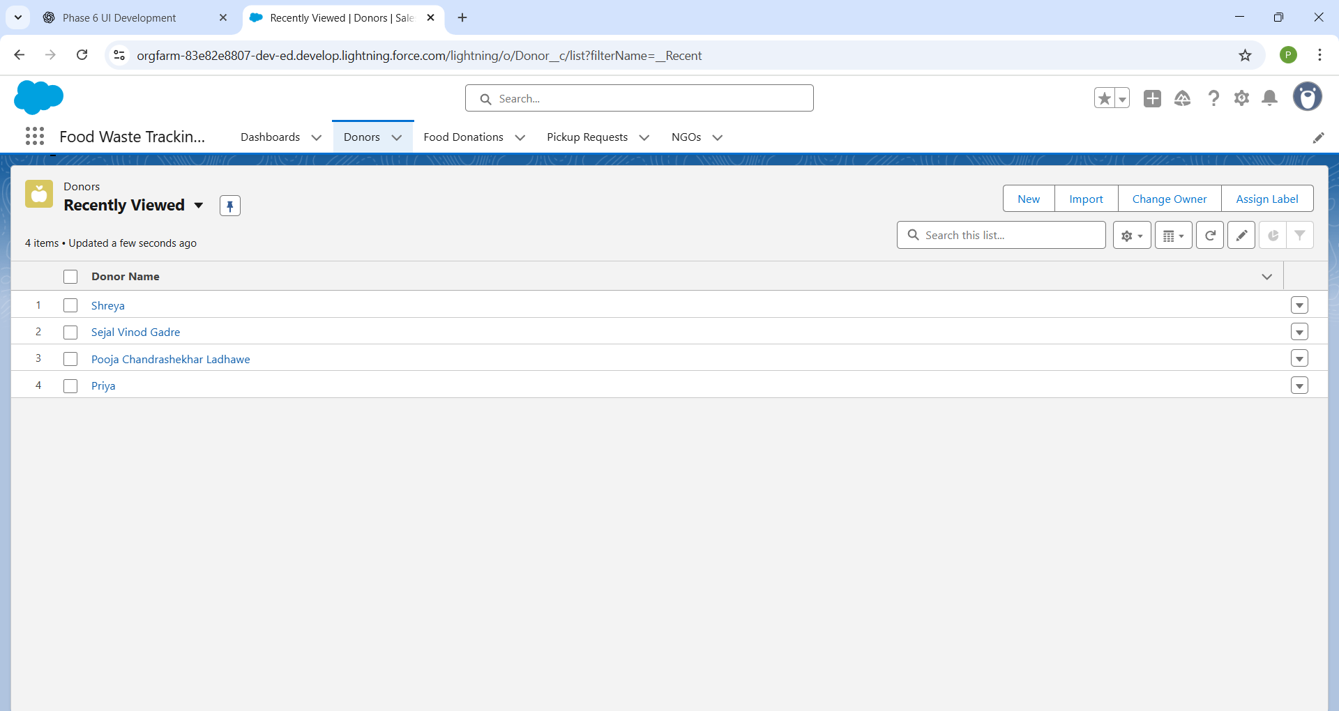

1. **Apex With LWC**
   * VS Code → Create LWCs for showing **Donation List, Pickup Requests, NGO Details**
   * Connect LWCs with Apex (e.g., DonationController)

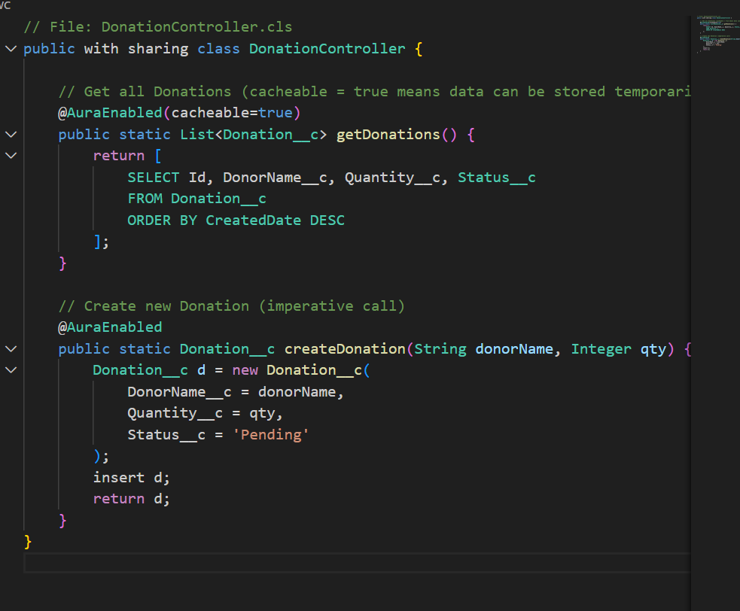

1. **Tabs**
   * Setup → Quick Find → Tabs → New Tabs for (NGO, Donor, Food Donation, Pickup Request)

1. **Quick Actions**
   * Setup → Object Manager → Food Donation → Buttons, Links, and Actions → New Action (e.g., **New Pickup Request**)
   * Setup → Object Manager → NGO → Buttons, Links, and Actions → New Action (e.g., **Assign Volunteer**)
2. **Reports**
   * Setup → Reports → Create Report → Example:
     + Food Donations by Donor
     + Pending Pickup Requests
     + NGO-wise Donations

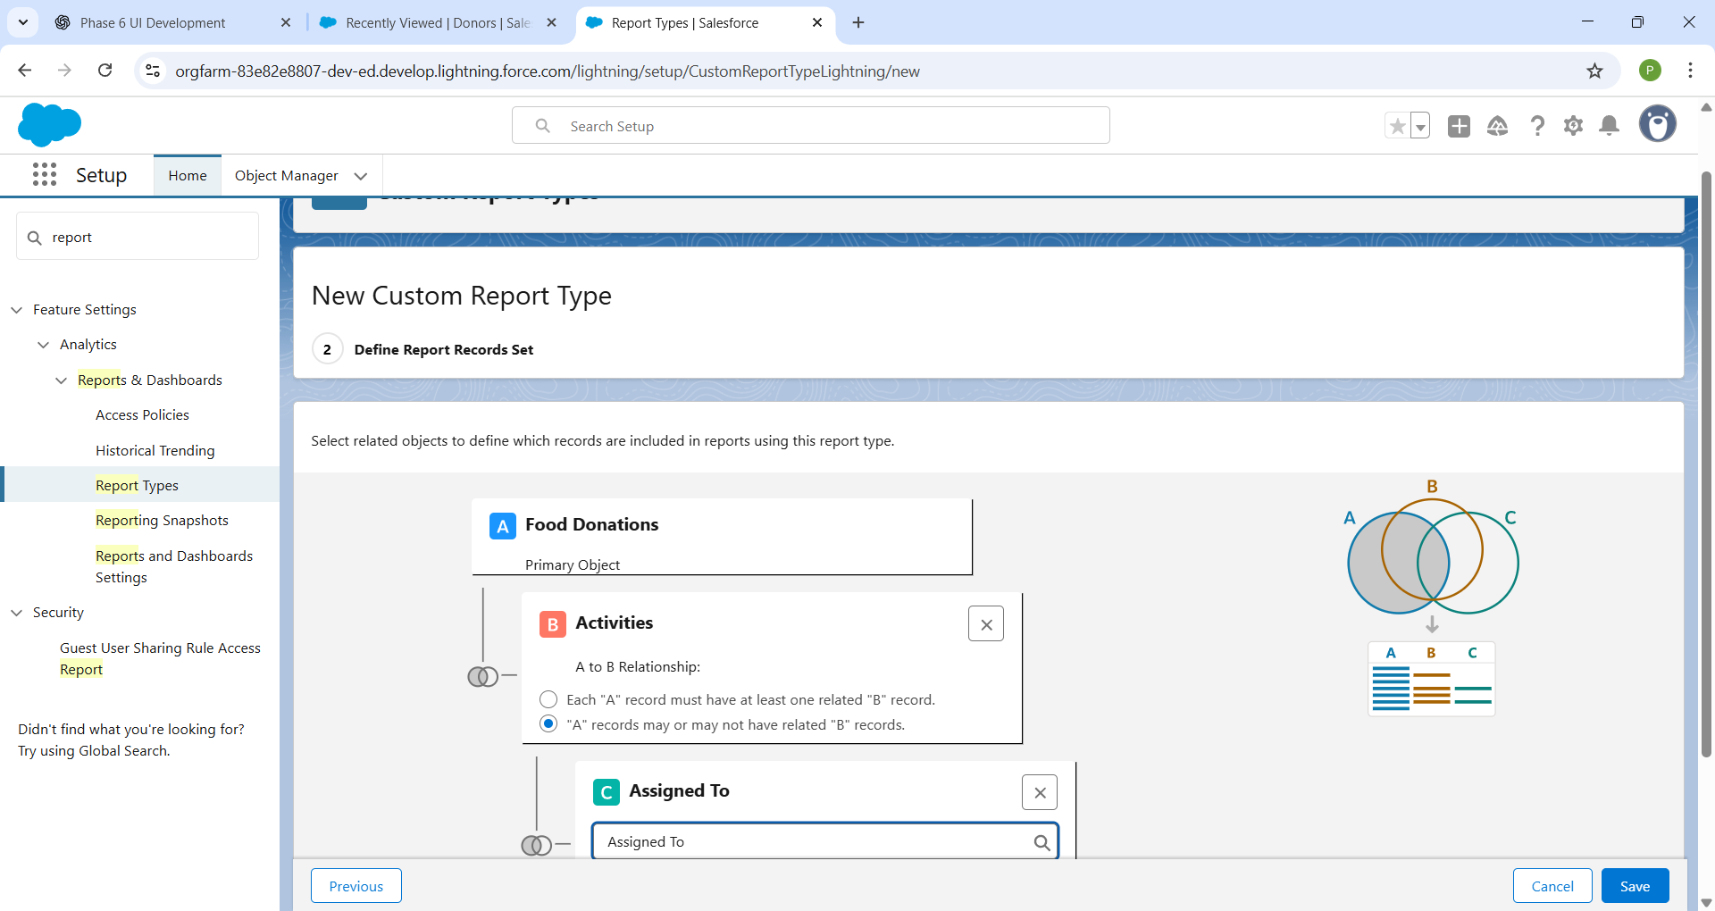

1. **Dashboard**
   * Setup → Dashboards → New Dashboard → Example:

